LAB Manual

PART A

(PART A : TO BE REFFERED BY STUDENTS)

**Experiment No. 8**

**A.1 Aim:** To perform System Audit.

**A.2 Prerequisite:**

Understanding on basics of audit system, use cases of audit system.

**A.3 Outcome:**

**After successful completion of this experiment students will be able to** Know about the tactics and techniques of system audit, tools used for system audit.

**A.4 Theory:**

**Audit:** An audit is the examination

**System Audit:** A system audit is an audit on a management system to validate whether or not the elements of the system are effective and properly implemented to meet the objectives or standards.

**Importance of system audit:** Strong audit systems can reduce or help decrease various forms of risks in businesses including the risk of material misstatement in financial reports. It also helps reduce the risk of misuse of assets, fraud and low quality management because of insufficient or lack of information on operations.

**Audit Benefits:**

1. Compliance.
2. Business Improvements / System Improvements.
3. Credibility.
4. Detect and Prevent Fraud.
5. Better Planning and Budgeting.

**Types of system audit:**

* Internal Audit.
* External Audit.
* Third Party Audit.
* Compliance Audit.

**Tools used for System Audit:**

* Compliance checklist.
* Inbuilt tools.
* Third party tools.

**Steps of performing a system audit:**

1. Review.
2. System Vulnerability is assessed.
3. Threats are identified.
4. Internal Controls are analyzed.
5. Final Evaluation.

Step: 1 Run CMD as administrator

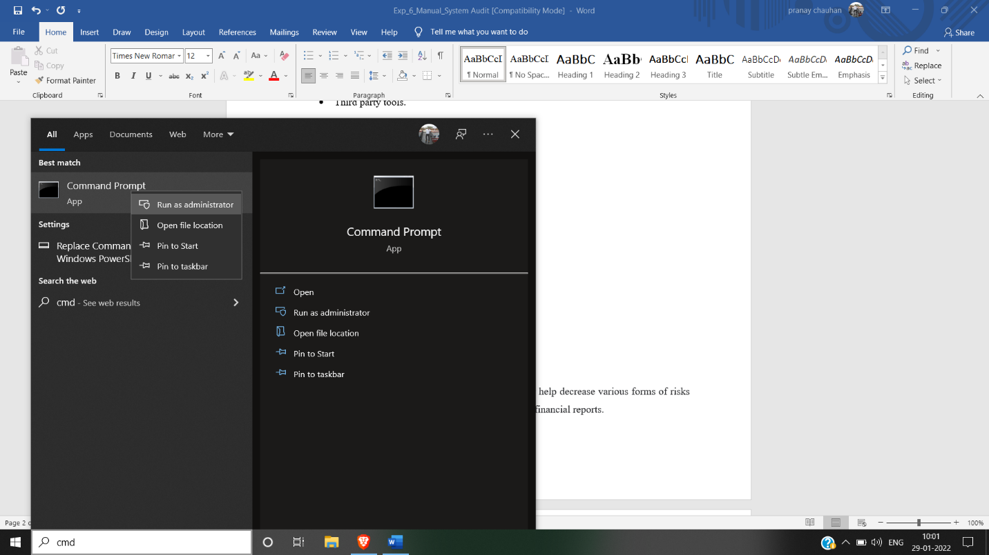

Step: 2

Check version of operating system to check updated version is used or not

Command : **ver**

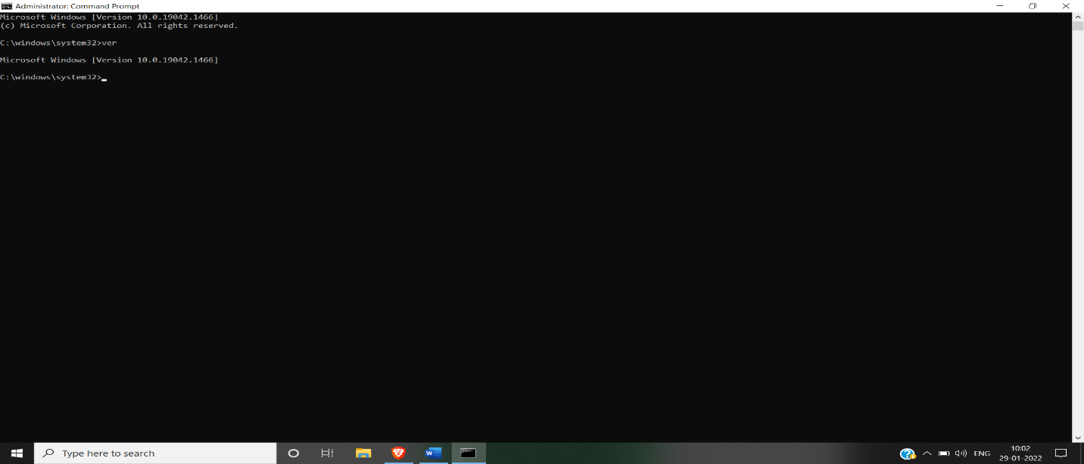

Step: 3: Check system information

To check all the updates

Command: systeminfo

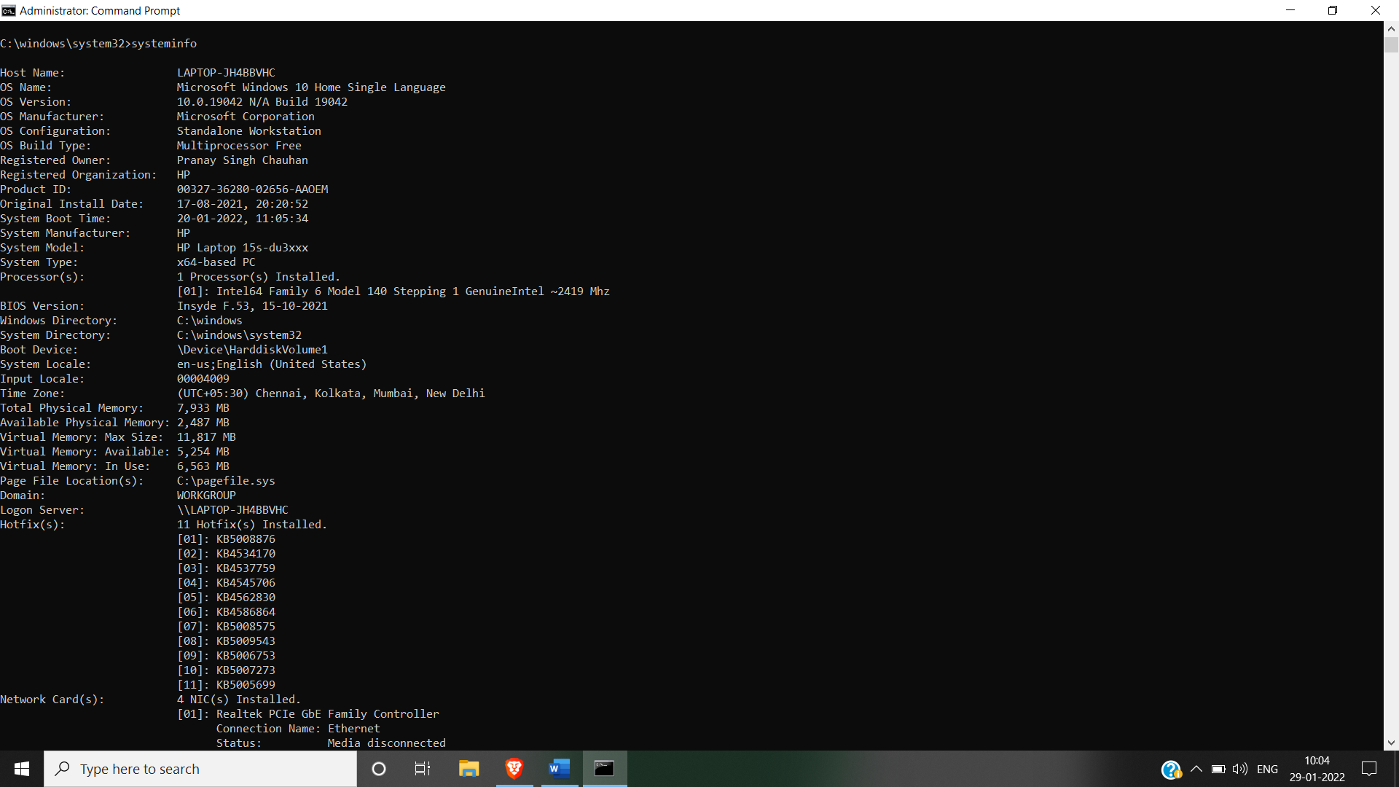

Step: 4: To check remotely open files

Command: openfiles



Step: 5: to Check all used wifi connections

Command: netsh wlan show profiles

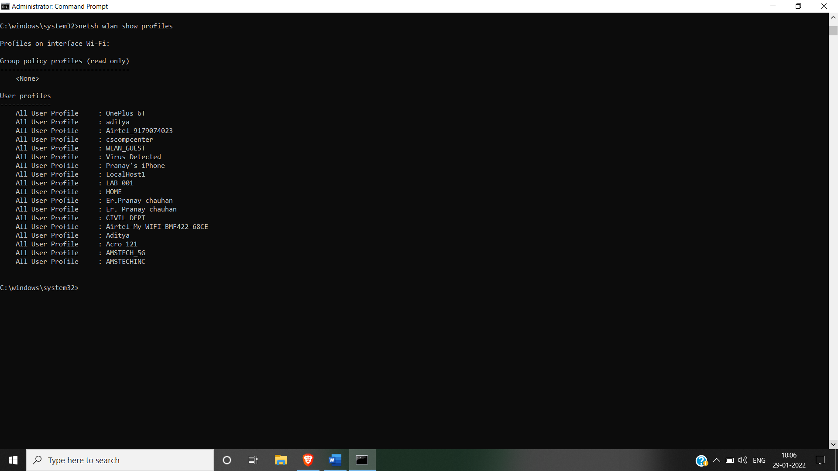

Step: 6 : To check firewall enabled services in desktop

Command : netsh advfirewall show currentprofile

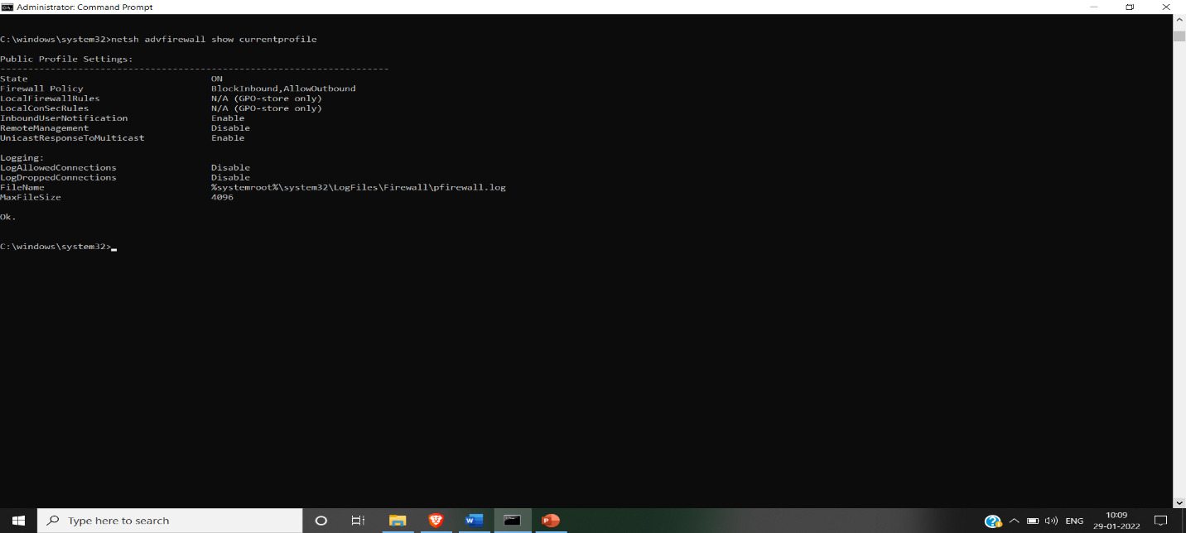

Step: 7: To check network account state

Command: net account

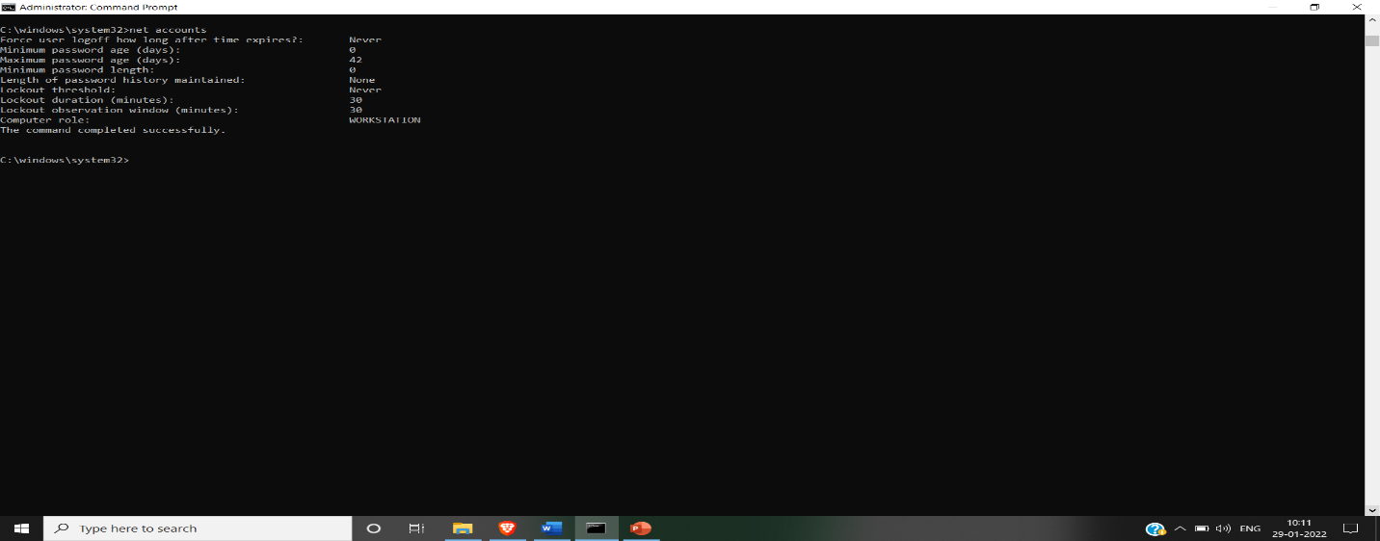

Step: 8: To check, scan and repair corrupted system file

Command: sfc/scannow

Step: 9: To check network files

Command: net file

Step: 10: To check all installed softwares

Command: Appwiz.cpl

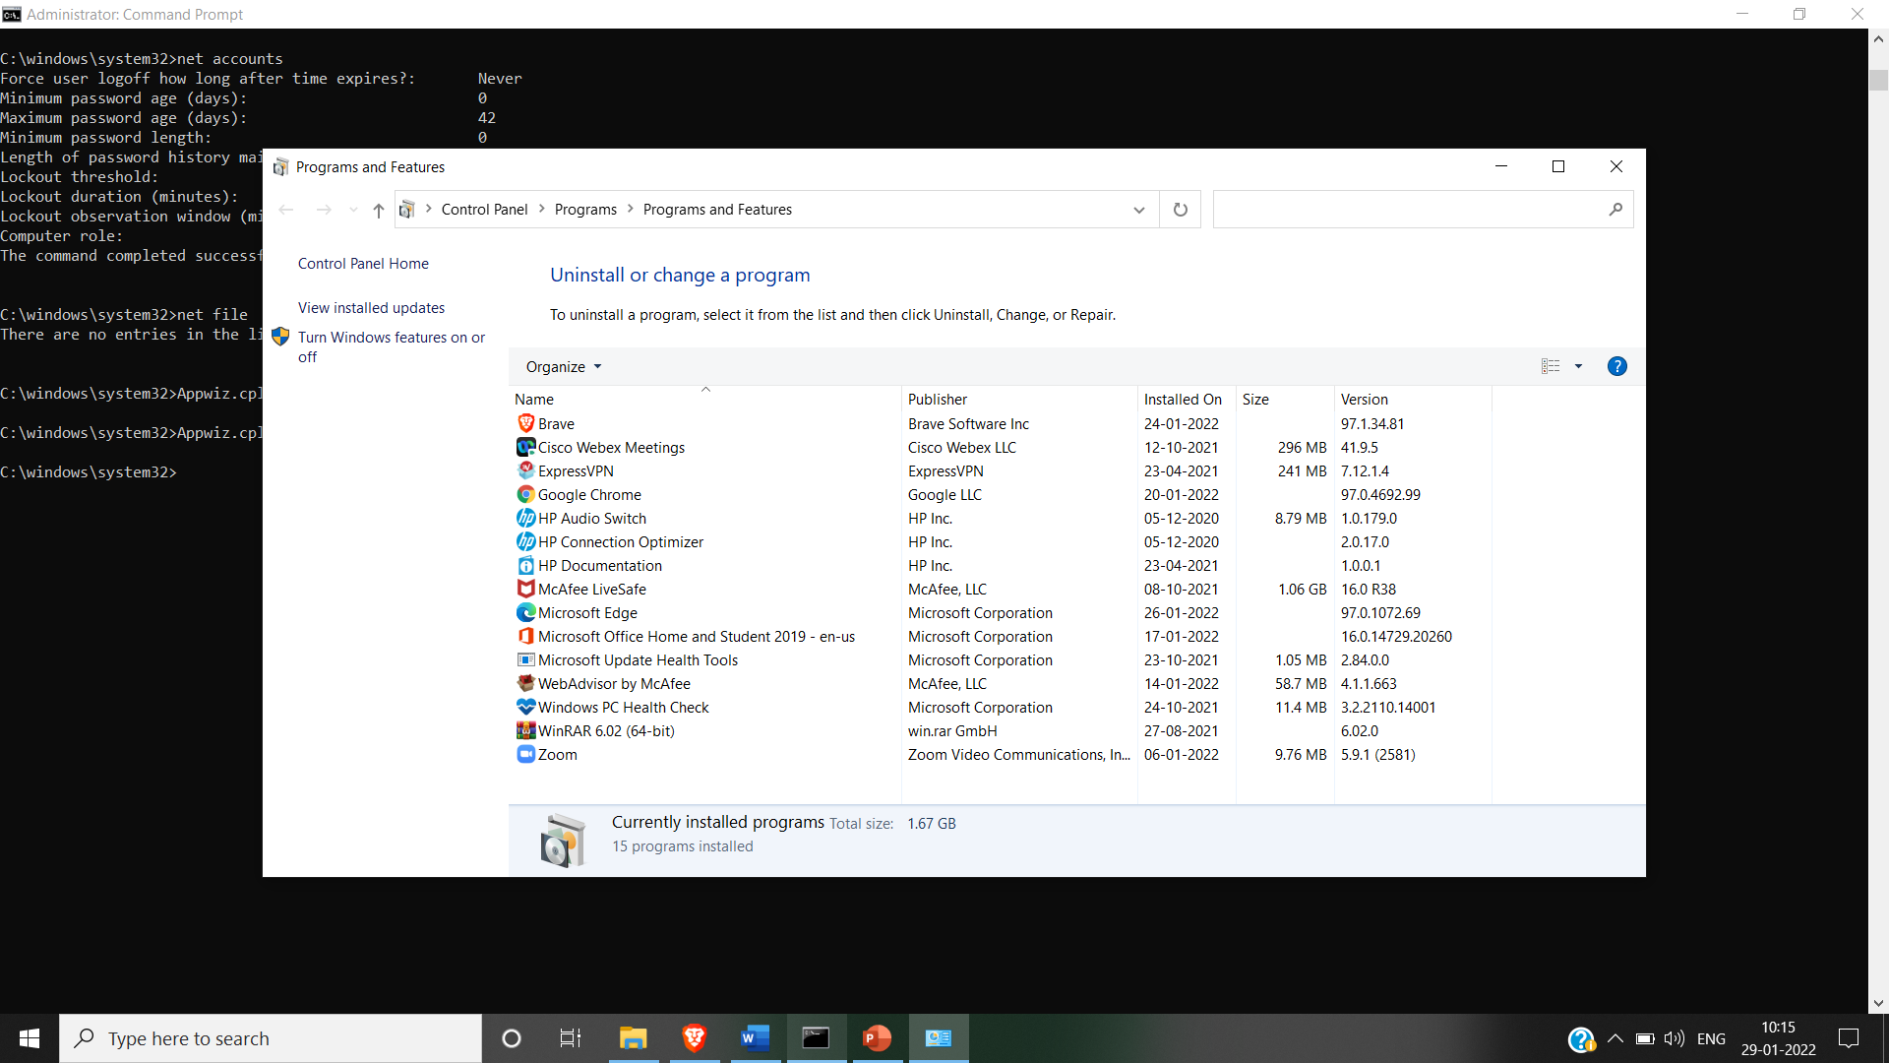

Other utilities can be used:

* query
* query termserver
* route table\
* route print
* arp –a
* services.msc (It will show all the services)

**Sample: Checklist for password policy**

**Password Policy**

* Is there any policy for minimum password characters?
* Did any mechanism for minimum password verification.
* Is there any two-step verification process for accessing passwords?
* Did Periodic password changes are mandatory
* Are there any options for least login attempts for user-entered passwords before blocking the account?
* Are there any options for password hints?
* Are there any options for multi-factor authentication (MFA)?

**Need of system Audit:** Strong audit systems can reduce or help decrease various forms of risks in businesses including the risk of material misstatement in financial reports.

It also helps reduce the risk of misuse of assets, fraud and low-quality management because of insufficient or lack of information on operations.

PART B

(PART B: TO BE COMPLETED BY STUDENTS)

***(Students must submit the soft copy as per following segments within two hours of the practical. The soft copy must be uploaded on the Blackboard or emailed to the concerned lab in charge faculties at the end of the practical in case the there is no Black board access available)***

|  |  |
| --- | --- |
| Roll. No. | Name: |
| Class | Batch: |
| Date of Experiment: | Date of Submission: |
| Grade: | |

**B.1 Software Code written by student:**

***(Paste your Java code completed during the 2 hours of practical in the lab here)***

**B.2 Input and Output:**

***(Paste your program input and output in following format, If there is error then paste the specific error in the output part. In case of error with due permission of the faculty extension can be given to submit the error free code with output in due course of time. Students will be graded accordingly.)***

**Input:**

System audit test cases

**Output:**

Output screenshots and inferences

**B.3 Observations and learning:**

***(Students are expected to comment on the output obtained with clear observations and learning for each task/ sub part assigned)***

**B.4 Conclusion:**

*(****Students must write the conclusion as per the attainment of individual outcome listed above and learning/observation noted in section B.3)***

**B.5 Questions of Curiosity**

***(To be answered by student based on the practical performed and learning/observations)***

Q1: Prepare audit checklist/ questionnaire based on above utilities.